UNIVERSITY INSTITUTE OF ENGINEERING AND TECHNOLOGY

PANJAB UNIVERSITY, CHANDIGARH



*B.E. Information Technology*

*(2021-25)*

* **Name :** Kunal
* **Roll no. :** UE218058
* **Section :** 2 (group-1)
* **Semester :** 1st / 2021-25 batch
* **File :** *Programming for problem solving*

*Practical File*

* **Submitted to – Prof. Monika Meena**

1. *Program for area of rectangle:*

**#include <stdio.h>**

**int main( )**

**{**

**float l; // 'l' is length of rectangle**

**float b; // 'b' is breadth of rectangle**

**printf("Enter the length of rectangle: ");**

**scanf("%f", &l);**

**printf("Enter the breadth of rectangle: ");**

**scanf("%f", &b);**

**printf("The area of rectangle is: %.2f sq.units", l*b);**

**return 0;**

**}**

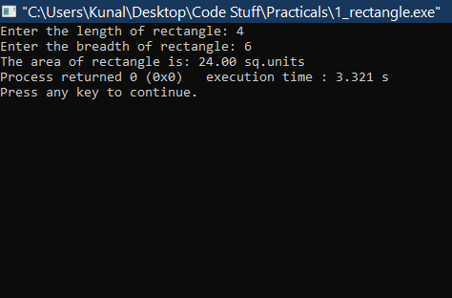

1. *Program for area of circle & then volume of cylinder w.r.t. its base :*

**#include <stdio.h>**

**int main( )**

**{**

**float r,area,h;**

**float pi=3.14;**

**printf("\n\nenter the radius & height: ");**

**scanf("%f%f", &r,&h);**

**area=pi*r*r;**

**printf("the area of circle is: %.2f\n", area);**

**printf("volume of cylinder is: %.2f\n\n\n", area*h);**

**return 0;**

**}**

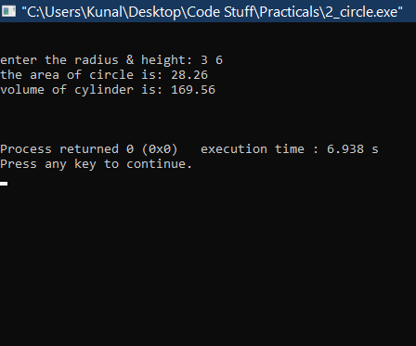

1. *Program for temperature conversion :*

**#include <stdio.h>**

**int main( )**

**{**

**float celc; //temp in celcius**

**float fahr; //temp in fahrenheit**

**printf("Enter celcius temp: ");**

**scanf("%f", &celc);**

**fahr= (celc*1.8)+32;**

**printf("Temperature in fahrenheit is: %.2f\n", fahr);**

**return 0;**

**}**

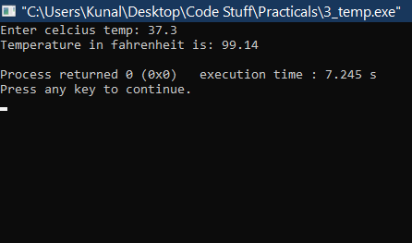

1. *Program for simple interest :*

**#include <stdio.h>**

**int main( ){**

**int n; // n is years**

**float p,r,si; /* p is princple amount**

**r is rate on interest**

**si is simple interest */**

**printf("Enter amount: "); scanf("%f", &p);**

**printf("Enter years: "); scanf("%d", &n);**

**printf("Enter rate of interest: "); scanf("%f",&r);**

**si= p*n*r/100;**

**printf("simple interest is: %.2f", si);**

**return 0;**

**}**

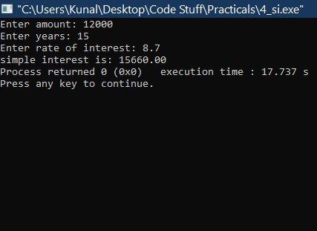

1. *Program for checking even/odd :*

**#include <stdio.h>**

**int main( ){**

**int i=0;**

**printf("enter the no. : ");**

**scanf("%d", &i);**

**if(i%2 !=0){**

**printf("entered no. is odd\n");**

**} else{**

**printf("entered no. is even\n");**

**}**

**return 0;**

**}**

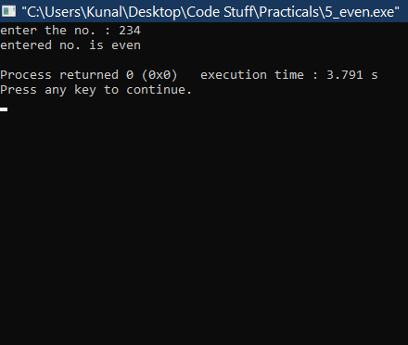 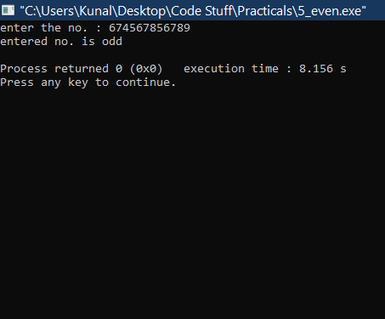

1. *Program for a leap year :*

**#include <stdio.h>**

**int main( ){**

**int y;**

**int i;**

**printf(“Enter the year: “);**

**scanf(“%d”, &y);**

**if(y%4 !=0 || (y/100)%4 !=0){**

**printf(“Its not a leap year\n”);**

**} else {**

**printf(“Its a leap year\n”);**

**}**

**return 0;**

**}**

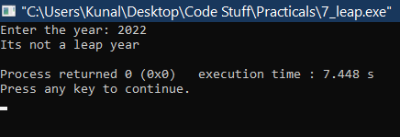 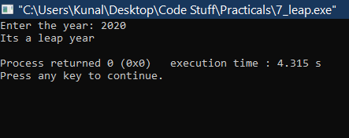

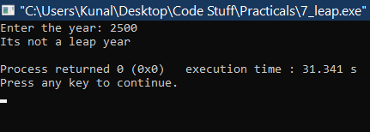

1. *Program for factorial of any no. entered through keyboard :*

**#include <stdio.h>**

**int main( ){**

**int i;**

**int k;**

**int factorial_i =1;**

**printf("Enter the number: ");**

**scanf("%d", &i);**

**for(k=1;k<=i;k++){**

**factorial_i *= k;**

**}**

**printf("Factorial of entered no. is: %d\n", factorial_i);**

**return 0;**

**}**

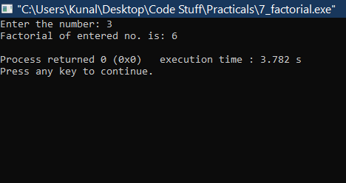 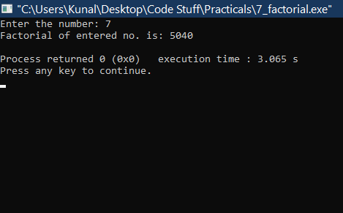

1. *Program for calculating table of a no. entered through keyboard :*

**#include <stdio.h>**

**int main( ){**

**int i;**

**printf("Enter the no. ");**

**scanf("%d", &i);**

**printf("The table for %d is:\n ", i);**

**for(int k=1; k<=10; k++){**

**int t;**

**t= k*i;**

**printf("%d\n", t);**

**}**

**return 0;**

**}**

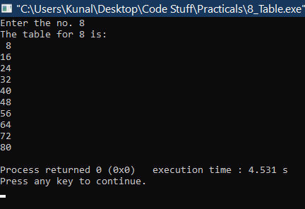 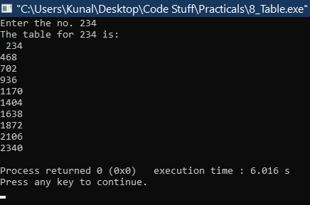

1. *Program for table of 10 in reverse order :*

**#include <stdio.h>**

**int main(){**

**printf("The table of 10 in reverse order is :\n");**

**for(int i=10; i>=1; i--){**

**int t;**

**t= i*10;**

**printf("%d\n", t);**

**}**

**return 0;**

**}**

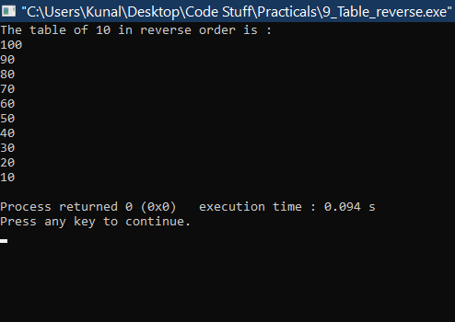

1. *(i) Program to sum first ten natural numbers (using while loop)*

**#include <stdio.h>**

**int main(){**

**int i=1;**

**int sum=0;**

**while (i<=10)**

**{**

**sum +=i;**

**i++;**

**}**

**printf("Sum of first ten natural no. is %d.\n", sum);**

**return 0;**

**}**

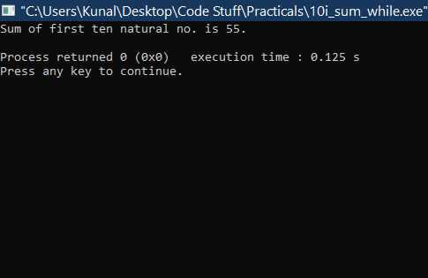

1. *.(ii) Program to sum first ten natural numbers (using for loop) :*

**#include <stdio.h>**

**int main(){**

**int sum=0;**

**for (int i= 1; i < 11; i++)**

**{**

**sum +=i;**

**}**

**printf("%d\n", sum);**

**return 0;**

**}**

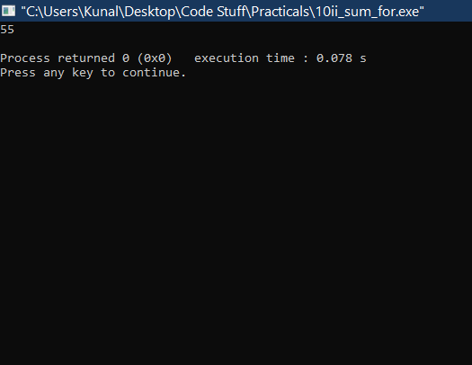

1. *. (iii) Program to sum first ten natural numbers (using do- while loop):*

**#include <stdio.h>**

**int main(){**

**int i=1;**

**int sum=0;**

**do**

**{**

**sum+=i;**

**i++;**

**} while (i>=1 && i<11 );**

**printf("%d\n", sum);**

**return 0;**

**}**

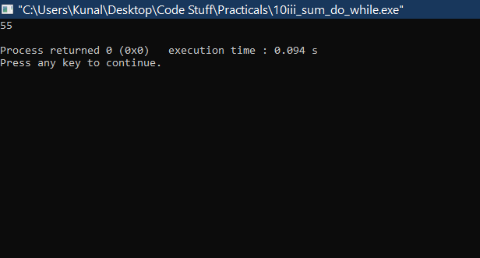

1. *. (i) Program for factorial of a number (****using ‘for’ loop****) :*

**#include <stdio.h>**

**int main(){**

**int x; // number**

**int f=1; // factorial**

**printf("enter the no. : ");**

**scanf("%d", &x);**

**for(int i=1; i<=x; i++){**

**f*= i;**

**}**

**printf("the factorial of no. is : %d\n", f);**

**return 0;**

**}**

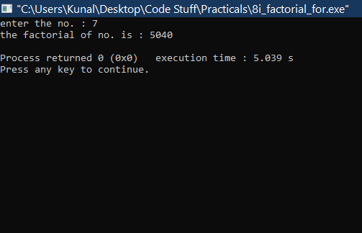

*11 . (ii) Program for factorial of a number (****using ‘while’ loop****) :*

**#include <stdio.h>**

**int main(){**

**int i=1;**

**int fact=1;**

**printf("Enter the no. : ");**

**scanf("%d",&i);**

**while (i>=1){**

**fact *= i;**

**i--;**

**}**

**printf("The factorial of given no. is : %d\n", fact);**

**return 0;**

**}**

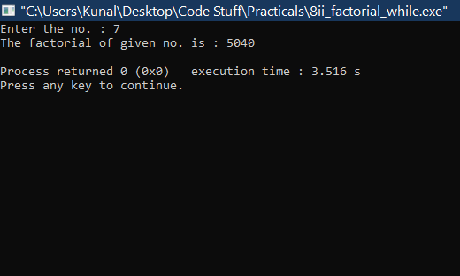

*12 . Program to calculate nth element of Fibonacci sequence :*

**#include <stdio.h>**

**int fibo(int i);**

**int main() {**

**int i;**

**int x;**

**printf("enter element no. : ");**

**scanf("%d",&x);**

**for (i = 1; i <= x; i++) {**

**printf("%d\t\n", fibo(i));**

**}**

**return 0;**

**}**

**int fibo(int i){**

**if(i==0) {**

**return 1;**

**}**

**if(i==1){**

**return 1;**

**}**

**return fibo(i-1) + fibo(i-2);**

**}**

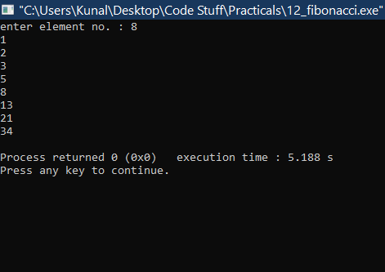 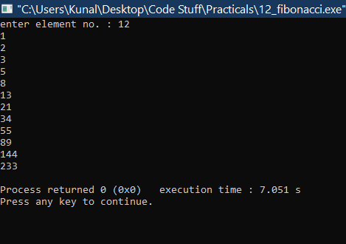

1. *. Program for calculating sum of first n natural no. :*

**#include <stdio.h>**

**int addNumbers(int n);**

**int main() {**

**int num;**

**printf("Enter a positive integer: ");**

**scanf("%d", &num);**

**printf("Sum = %d", addNumbers(num));**

**return 0;**

**}**

**int addNumbers(int n) {**

**if (n != 0)**

**return n + addNumbers(n - 1);**

**else**

**return n;**

**}**

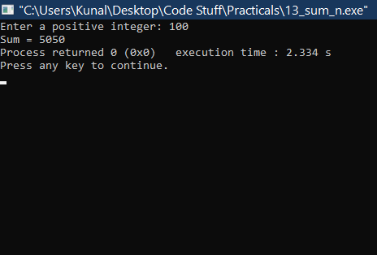**s**

*14 . Program for printing star pattern :*

**#include <stdio.h>**

**int rows;**

**int star(rows);**

**int main() {**

**printf("Enter the number of rows: ");**

**scanf("%d", &rows);**

**star(rows);**

**return 0;**

**}**

**int star(rows){**

**int i, j;**

**for (i = 1; i <= rows; ++i) {**

**for (j = 1; j <= i; ++j) {**

**printf("* ");**

**}**

**printf("\n");**

**}**

**return 0;**

**}**

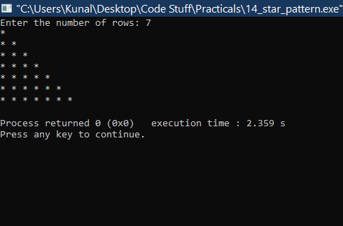

*15.(a). Program for inserting sub-string:*

**#include<stdio.h>**

**#include<string.h>**

**int main() {**

**char n[] = "New";**

**char y[] = " York";**

**char c[] = " City";**

**strcat(n, y);**

**strcat(n, c);**

**printf("%s\n", n);**

**}**

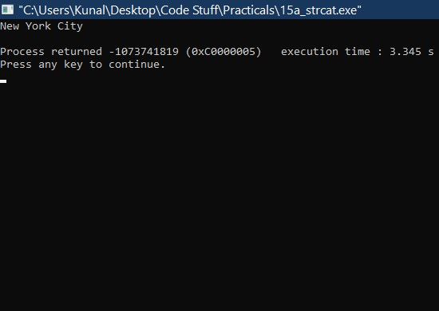

*15.(b). (i) Program for swapping values ( call by value ) :*

**#include <stdio.h>**

**void swapv ( int x, int y ) ;**

**int main( )**

**{**

**int a = 43, b = 34 ;**

**swapv ( a, b ) ;**

**printf ( "a = %d b = %d\n", a, b ) ;**

**return 0 ;**

**}**

**void swapv ( int x, int y )**

**{**

**int t ;**

**t = x ;**

**x = y ;**

**y = t ;**

**printf ( "x = %d y = %d\n", x, y ) ;**

**}**

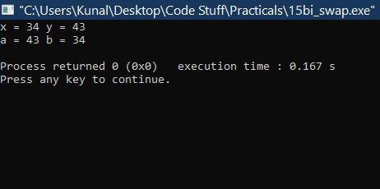

*15.(b). (ii) Program for swapping values ( call by reference ) :*

**# include <stdio.h>**

**void swapr ( int *, int * ) ;**

**int main( )**

**{**

**int a = 53, b = 35 ;**

**swapr ( &a, &b ) ;**

**printf ( "a = %d b = %d\n", a, b ) ;**

**return 0 ;**

**}**

**void swapr ( int *x, int *y )**

**{**

**int t ;**

**t = *x ;**

**\*x = *y ;**

**\*y = t ;**

**}**

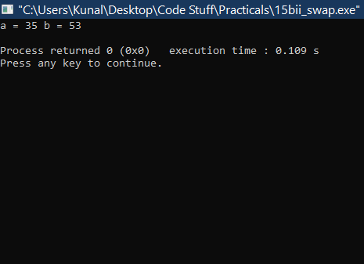

*16.(a). Program for finding GCD of two numbers ( using recursion ) :*

**#include <stdio.h>**

**int hcf(int n1, int n2);**

**int main() {**

**int n1, n2;**

**printf("Enter two positive integers: ");**

**scanf("%d %d", &n1, &n2);**

**printf("G.C.D of %d and %d is %d.\n ", n1, n2, hcf(n1, n2));**

**return 0;**

**}**

**int hcf(int n1, int n2) {**

**if (n2 != 0)**

**return hcf(n2, n1 % n2);**

**else**

**return n1;**

**}**

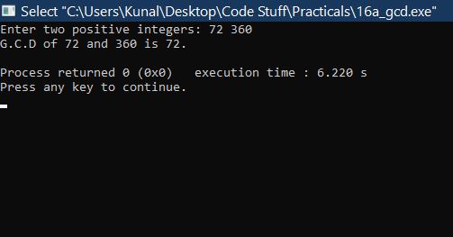

*16.(b). Program for finding GCD of two numbers ( using non- recursion ) :*

**#include <stdio.h>**

**int main()**

**{**

**int n1, n2, i, gcd;**

**printf("Enter two integers: ");**

**scanf("%d %d", &n1, &n2);**

**for(i=1; i <= n1 && i <= n2; ++i)**

**{**

**// Checks if i is factor of both integers**

**if(n1%i==0 && n2%i==0)**

**gcd = i;**

**}**

**printf("G.C.D of %d and %d is %d", n1, n2, gcd);**

**return 0;**

**}**

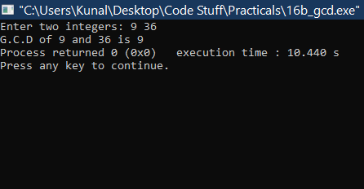

*17. (a) Program for finding largest & smallest number in a list :*

**#include<stdio.h>**

**int main(){**

**int a[50],i,num,large,small;**

**printf("Enter the number of elements :");**

**scanf("%d",&num);**

**printf("Input the array elements :\n\n");**

**for(i=0;i<num;++i)**

**scanf("%d",&a[i]);**

**large=small=a[0];**

**for(i=1;i<num;++i){**

**if(a[i]>large)**

**large=a[i];**

**if(a[i]<small)**

**small=a[i];**

**}**

**printf("\nsmallest= %d\n",small);**

**printf("largest= %d\n",large);**

**return 0; }**

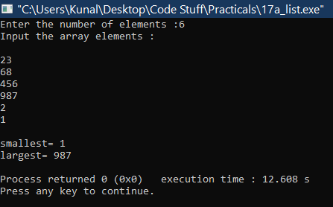

*17.(b). Program for sorting array in ascending order :*

**#include <stdio.h>**

**void main ( ){**

**int num[20];**

**int i, j, a, n;**

**printf("enter number of elements in an array\n");**

**scanf("%d", &n);**

**printf("Enter the elements\n");**

**for (i = 0; i < n; ++i)**

**scanf("%d", &num[i]);**

**for (i = 0; i < n; ++i){**

**for (j = i + 1; j < n; ++j){**

**if (num[i] > num[j]){**

**a = num[i];**

**num[i] = num[j];**

**num[j] = a;**

**}**

**}**

**}**

**printf("The numbers in ascending order is:\n");**

**for (i = 0; i < n; ++i){**

**printf("%d\n", num[i]);**

**}**

**}**

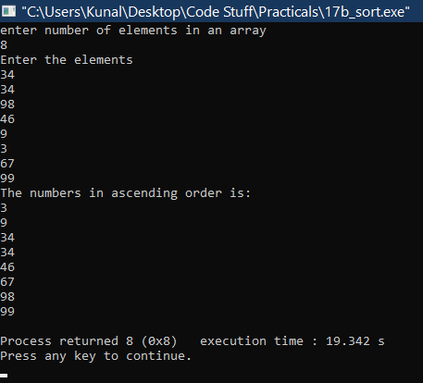

*17.(c) Program for checking if a matrix is symmetric or not :*

**#include<stdio.h>**

**int main()**

**{**

**int i, j, rows, columns, a[10][10], b[10][10], Count = 1;**

**printf("\n Please Enter Number of rows and columns : ");**

**scanf("%d %d", &i, &j);**

**printf("\n Please Enter the Matrix Elements \n");**

**for(rows = 0; rows < i; rows++){**

**for(columns = 0;columns < j;columns++){**

**scanf("%d", &a[rows][columns]);**

**}**

**}**

**//Transpose of matrix**

**for(rows = 0; rows < i; rows++){**

**for(columns = 0;columns < j; columns++){**

**b[columns][rows] = a[rows][columns];**

**}**

**}**

**for(rows = 0; rows < i; rows++){**

**for(columns = 0; columns < j; columns++){**

**if(a[rows][columns] != b[rows][columns]){**

**Count++;**

**break;**

**}**

**}**

**}**

**if(Count == 1) {**

**printf("\n The Matrix that you entered is a Symmetric Matrix ");**

**}else**

**{**

**printf("\n The Matrix that you entered is Not a Symmetric Matrix ");**

**}**

**return 0;**

**}**

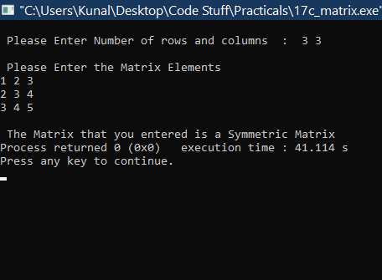

*18. Program* *to count the number of lines, words and characters in a given text :*

**#include<stdio.h>**

**int main()**

**{**

**// declare variables**

**char str[200];**

**int line, word, ch;**

**// initialize count variables with zero**

**line = word = ch = 0;**

**// read multiline string**

**printf("Enter string terminated with ~ :\n\n");**

**scanf("%[^~]", str);**

**// check every character**

**for(int i=0; str[i]!='\0'; i++)**

**{**

**// if it is new line then**

**// one line and one word completed**

**if(str[i]=='\n')**

**{**

**line++;**

**word++;**

**}**

**// else it is a character**

**else**

**{**

**// if character is space or tab**

**// then one word is also completed**

**if(str[i]==' '||str[i]=='\t')**

**{**

**word++;**

**ch++;**

**}**

**// it was not '\n', sapace or tab**

**// it is a normal character**

**else {**

**ch++;**

**}**

**}**

**}**

**// display count values**

**printf("\nCharacter counts = %d\n", ch);**

**printf("Word counts = %d\n", word);**

**printf("Line counts = %d\n", line);**

**return 0;**

**}**

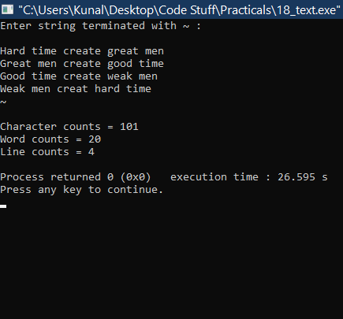

**.....*THE – END***